**Piduri võimalikud lahendused**

**Elektriline**

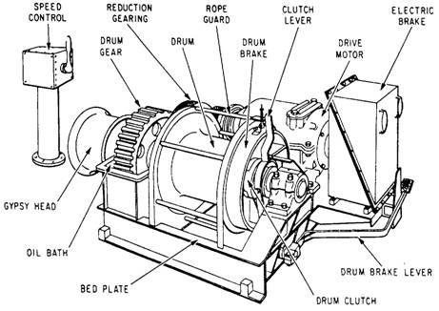

**Lint**

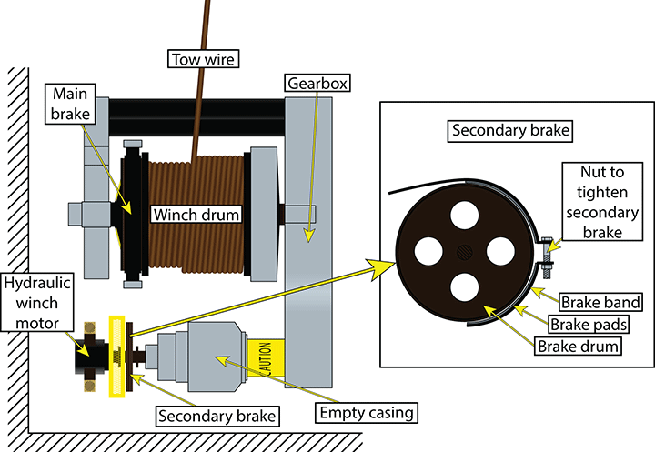

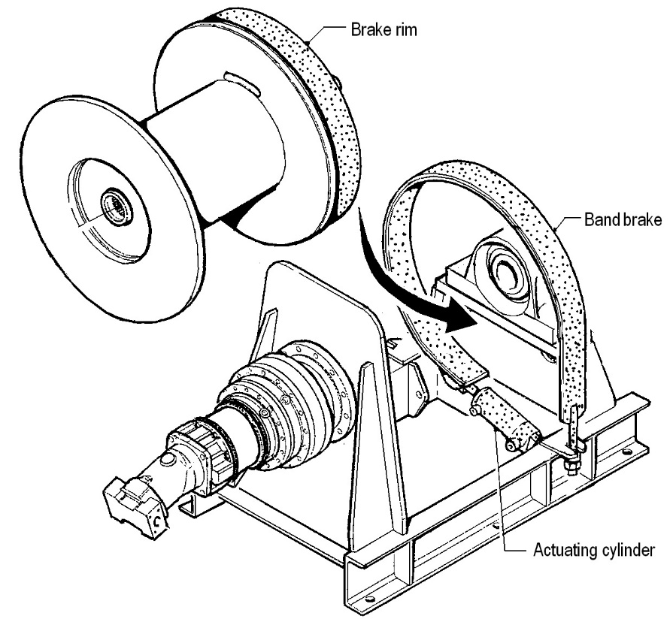

<https://emce.com/about-winches>

**Hüdraulilised pidurid**

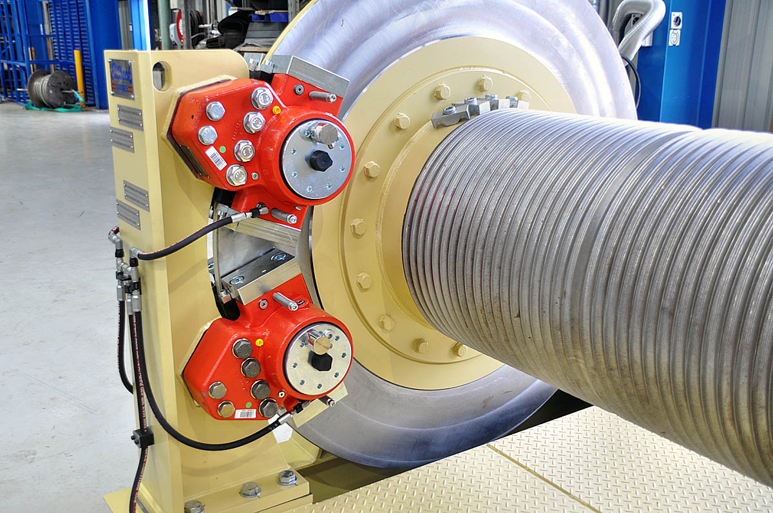

**Mootori pidur**

**Load Brakes**

An alternative to using a double brake on the motor side would be to place one brake on the output (gearbox) side of the machine in addition to the gearmotor brake.  This output brake is typically referred to as a load brake or parking brake.

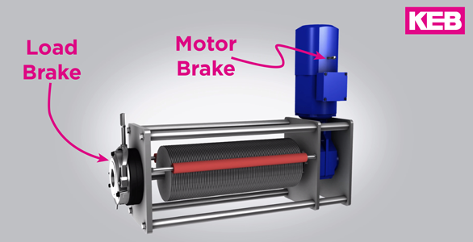

<https://kebblog.com/theatre-brakes-for-hoists-and-winches/>

**Ketaspidur**

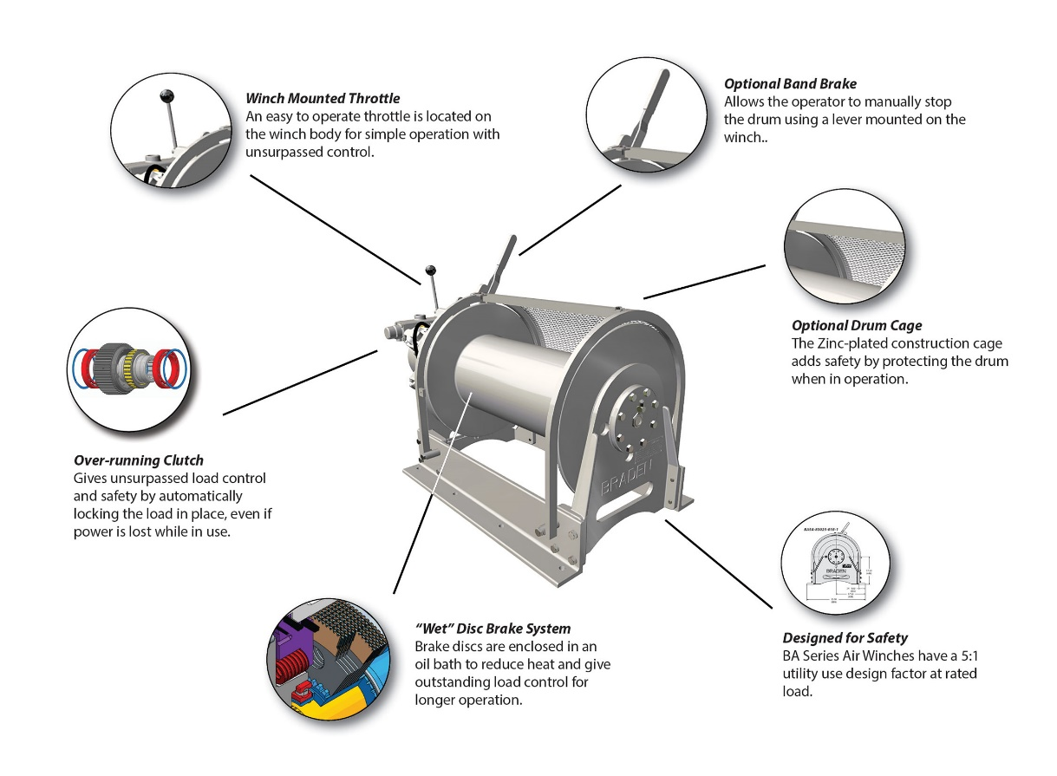

<https://www.paccarwinch.com/products/category/99>

**Põrkratas**

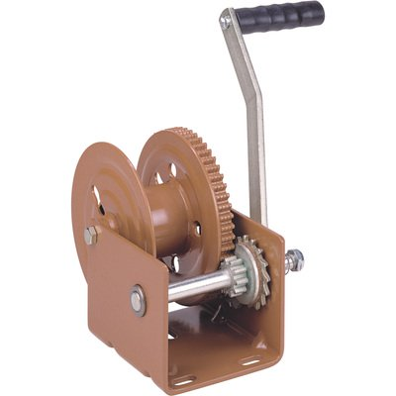

**Klotsipidur**

