http://www.scribd.com/doc/101193603/BE-Thesis-of-UAV-Quad-Copter

CHAPTER 3
DESIGN OF QUADCOPTER
3.1 Mechanical Design of Quadcopter:

Basic Designb.

Material Selectionc.

Design Calculations
3.1.1

Basic Design
The basic design consists of two links attached together in a cross formation. The links are reinforced at the center by plates. Motors are mounted at the end of the links.
Fig3.1: The basic Quad copter schematic
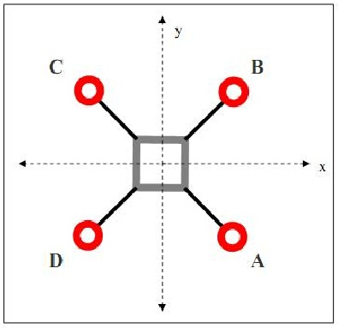
Fig3.1: The basic Quad copter schematic

